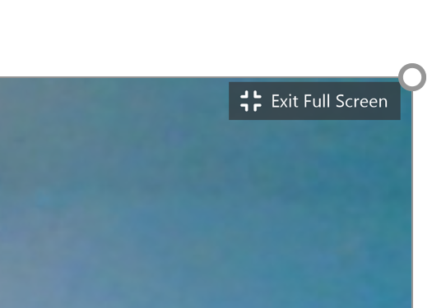
How to Minimize in Zoom
- Click Exit full screen (roll mouse near top right corner)
- Click on the minus sign in the white bar across top
- You should see the CLEVER Portal
- If not click on the rainbow
Google Chrome browser at the bottom of the school chromebook (Go to Clever)
- Click on Mrs. Miller running icon to go to Team TK student page
- Choose your app (stmath, raz-kids, etc)
Close the App/Get Back to Zoom
- Black X out of the app
- Click on the blue Zoom icon in the task bar
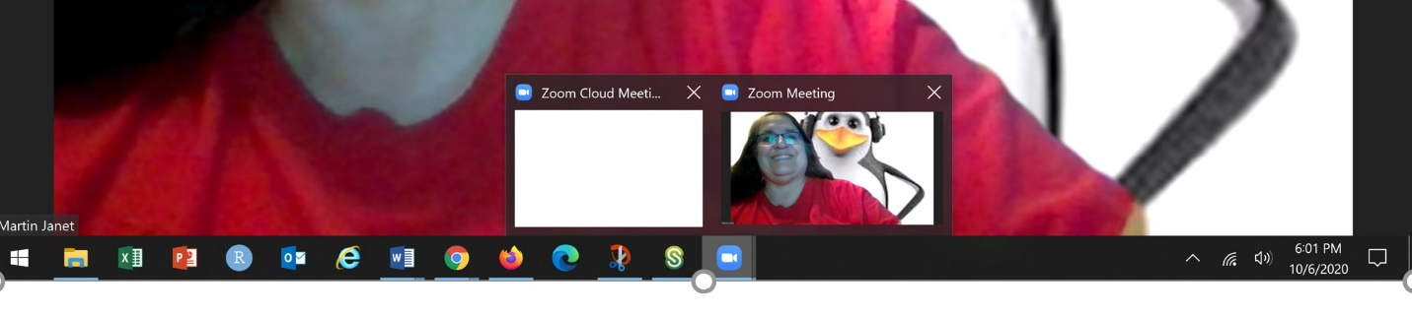
- Roll across the tiny picture that appears and click on the green arrow to enlarge your screen and
see your teacher and classmates again.

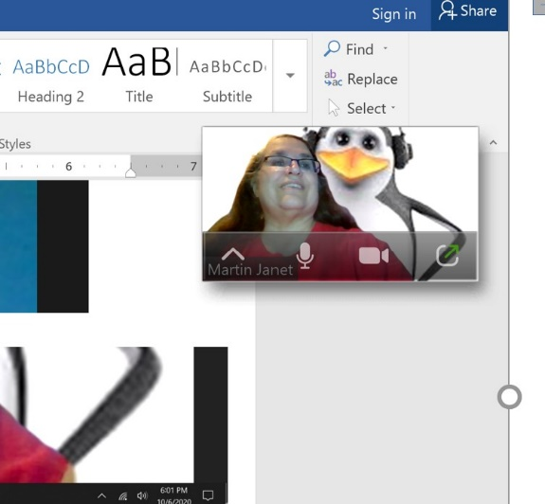
Ms. Martin and her alter ego Penguin Tech
Choose the green arrow
Choose the picture on the right

